REGISTERY INVESTIGATION
61. Registry editor open karo
regedit
SOC POV
Persistence detection.
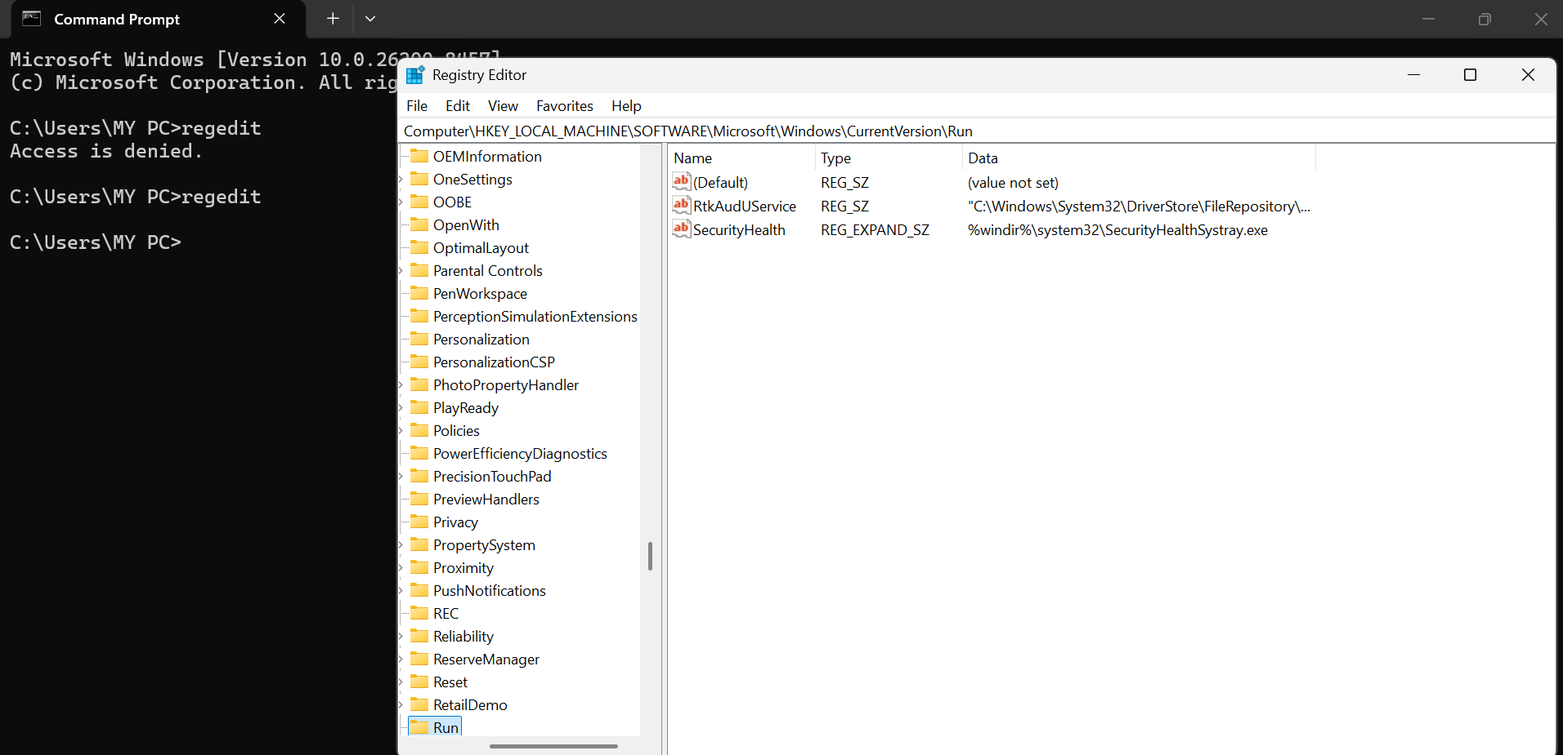
Check karna any key is unusual
(apko permission allow karni hoti hau user accont ko asai hi ni open hota vo)

62. Run key check
HKCU\Software\Microsoft\Windows\CurrentVersion\Run
SOC POV
Startup malware.
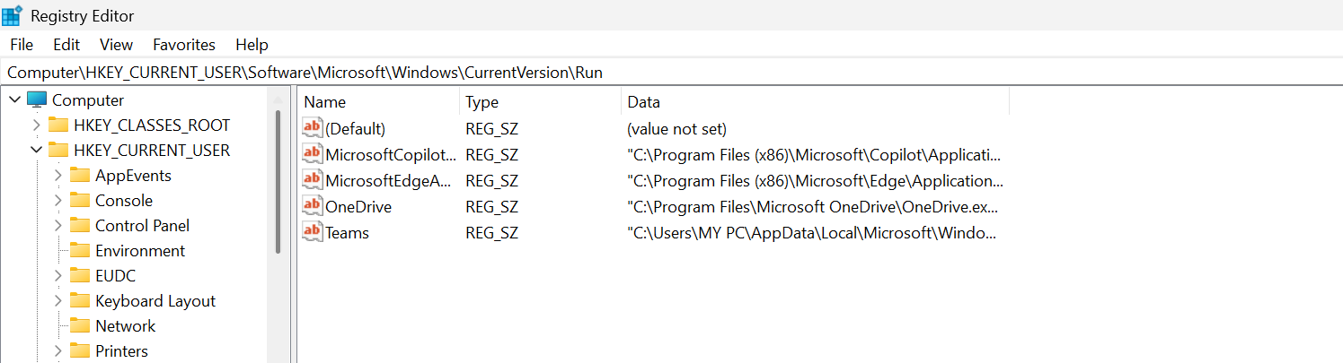
Always check this one
Right side mai only 4 (mere mai 4 hai )hote hai
- default that is for application
- one drive -file sync
- microft edge for background activity
- only these three are valid other that this suspicious
- ms teams
warning never delete legit program by mistake as it can affect destroy system configuarartion for save side always disable it by tab statup app tabs

63. Machine run key
HKLM\Software\Microsoft\Windows\CurrentVersion\Run
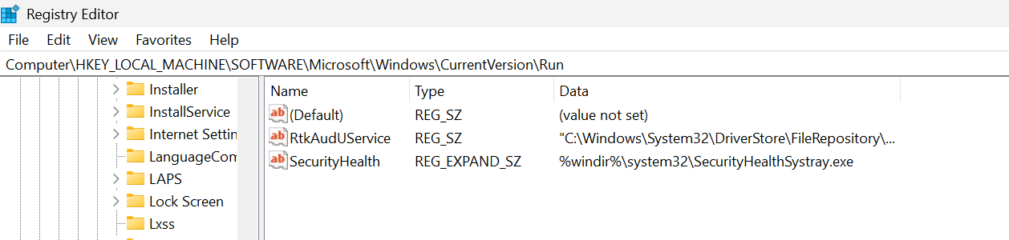
SOC POV
System level persistence.
Default – no value
rkAudio service– for hardware audio
security health for pc health monitoring
always monitor above two cause these are most prone to abuse
64. Startup programs check
Msconfig

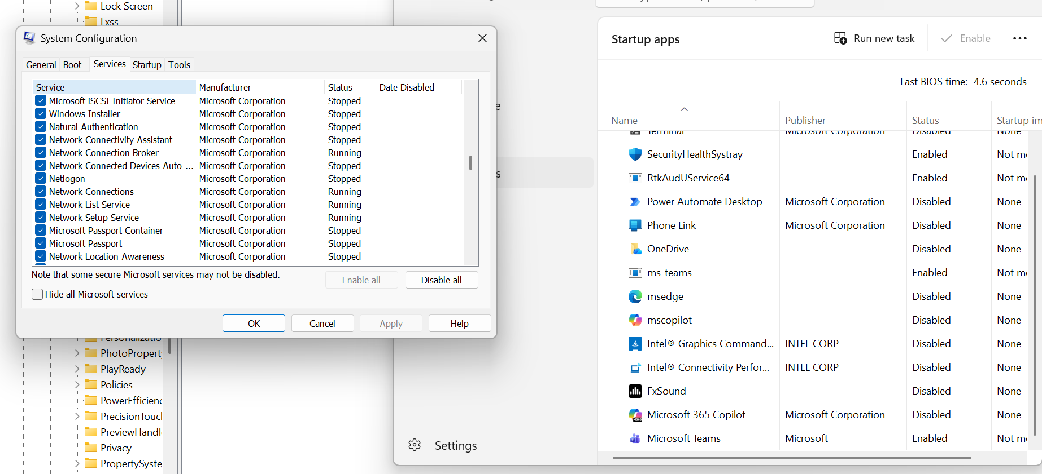
SOC POV
Hidden startup malware.
Open Karega ek block -
- Usme app check karenge service column yeh dekhe koi unkown service to nahi run hori
- Startup columb dekhne k liye konsa konse startup service hai

65. Installed programs check
appwiz.cpl
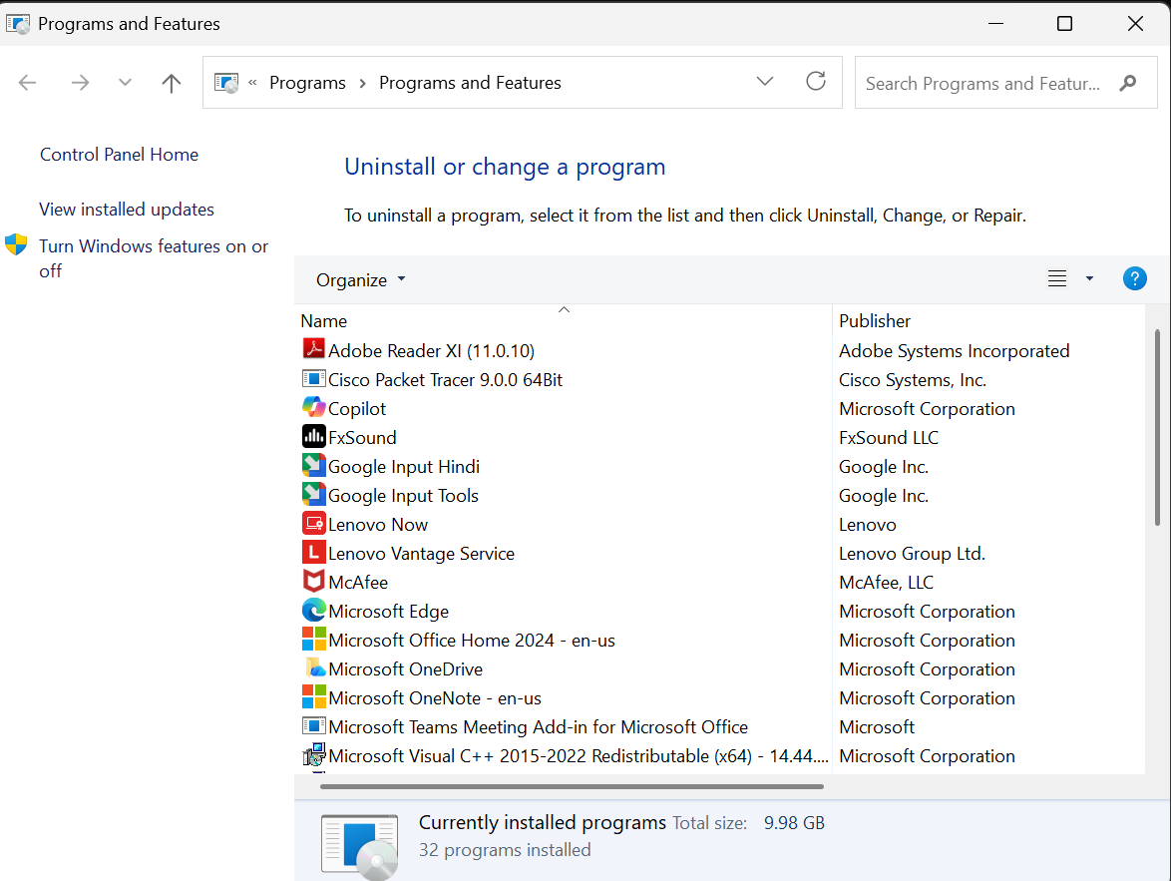
SOC POV
Suspicious software. (check ki suspicious koi appt o install ni hai)

66. Task scheduler open
taskschd.msc
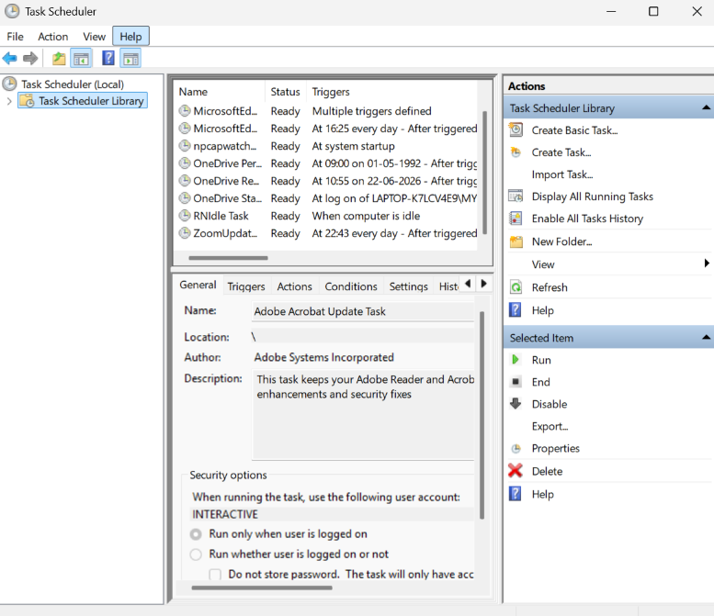
SOC POV
Scheduled malware.(isse app niche colum mai jaake dekh sakte ho konsa task kab schedule hora hia ya roj roj loop pe konse task chalre hai)

67. Services manager
services.msc
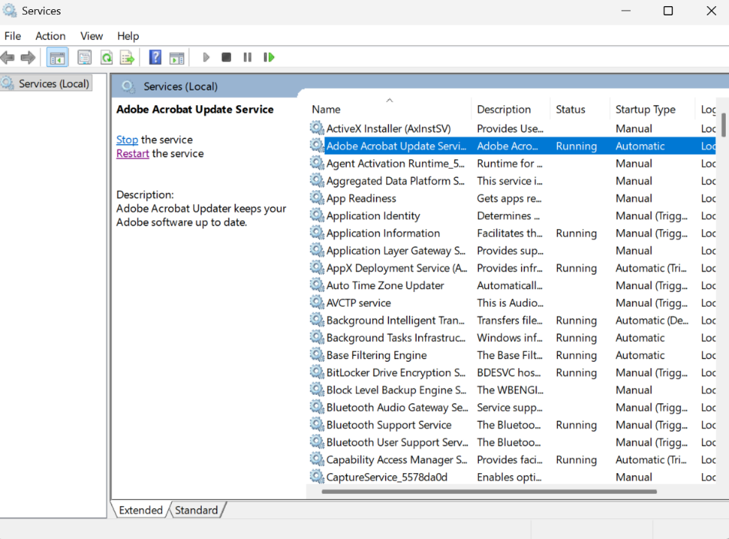
SOC POV
Malicious service.
Main to yeh hai ki apko name check karna bviously and path ki kaha hai yeh file kyuki sirf system 32 and program files mai hona chaiye uske alawa suspicious)

68. Local security policy
secpol.msc
SOC POV
Security misconfigurations.(not available at my window cause pro edition hai and yeh security of system )

69. Group policy
gpedit.msc
SOC POV
Attack persistence.(basically yeh rules define karta hai sare users k liye )

70. Registry autoruns detect
Tool
Autoruns
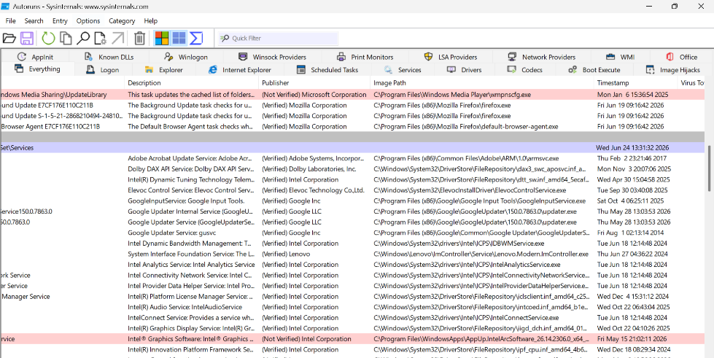
SOC POV
Advanced persistence detection.
Basically app yaha serices , drivers yeh sb jo hai check hoga and basically I me jo check hota hai
- Aggra red ho – to check name – path (basically temp, app inme ni hona chaiye)- publisher check karna hai bss (chota concern hai yeh )
- Aggra yellow ho rare hi dangerous hota hai kyuki basically kya hota hai file register mai store hoti hai file explorer mai nhai aur yhe ho sakta hia update k time but suspicious bhi ho sakta jab attacker malicious dll put karre but use del karde file explorer mai se but register mia to rehe hi jayga to dikhata hai yellow
- Bahut deeply analyse karta hai yeh tool logs ko aur app kuch bhi del nahi kar sakte kyuki aggar glti se kuch imp conf del ho gayi to system work nahi Karega properly

